Manufacturing Data Collection and Analytics

Option №3

**Prepared by:**

Sokolova Anna

Petrash Kirill

Abdallah Maryanna

Golubeva Alina

**Content/Task division:**

* Create VM and DB (Anna)
* Create DB structure (Anna)
* Python Script for parsing and loading data (Anna)
* Data preparation (Alina, Maryanna)
* Node-red MQTT Dashboard (Alina)
* Analysis in Python (Maryanna)
* Analysis in Excel (Alina, Maryanna)
* Create a Telegram bot(Kirill)
* Make notifications about errors and extreme values from sensors(Kirill)

# 

# 

# 

# 

# 

# 

# 

# Storage data

1. **First Step:**

Creating a virtual machine in VK Cloud and setting up a database with access for all is a structured task that involves several critical steps. First, we registered with VK Cloud, accessing their website.

Once we're logged into the VK Cloud portal, we navigated to the "Virtual Machines" section and initiated the creation of a new VM. We fulfilled all necessary required settings.

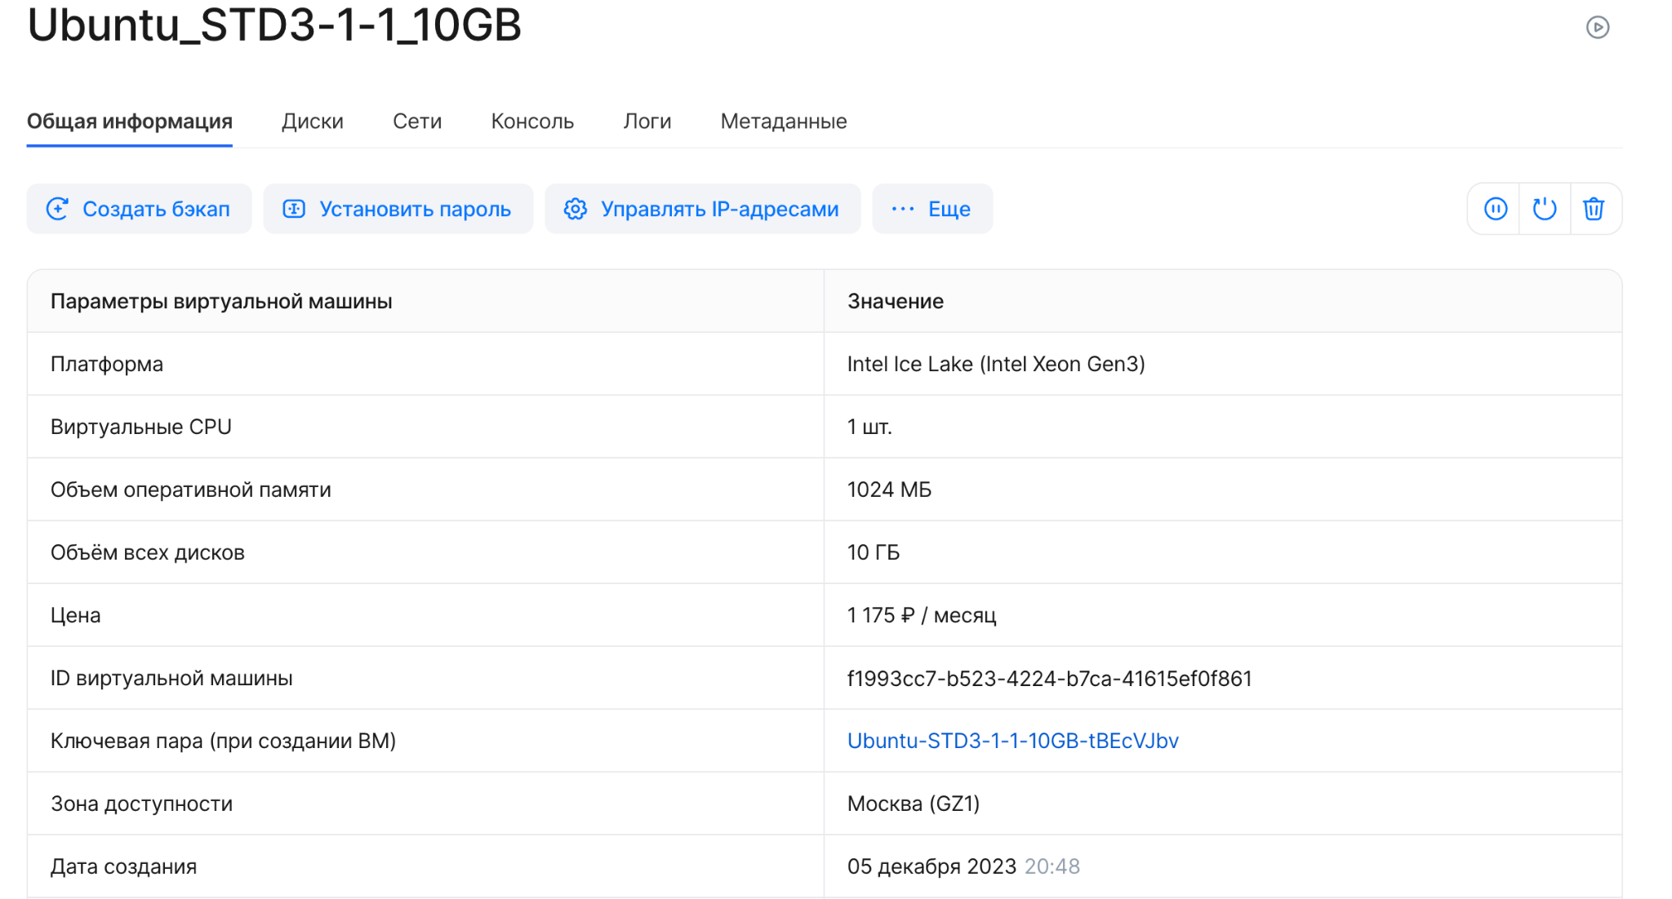

1. **Second Step:**

In the next phase, With the VM set up, I connect to it using SSH. SSH keys are the more secure authentication method compared to passwords.

The next order of business is installing the database management system, like PostgreSQL. I updated the system's packages first for good measure. Installing PostgreSQL on a Linux VM involves a simple apt command, followed by starting the PostgreSQL service.

Now, with the database service running, we switch to the ‘postgres’ user and dive into the PostgreSQL interactive shell with the ‘psql’ command. Here, we created a new database and a user with a password. Granting privileges to the user over the newly created database ensures they have the necessary access.

Remote access requires tweaking the PostgreSQL configuration files—‘pg_hba.conf’ and ‘postgresql.conf’—to accept connections from specific IP addresses and listen on the appropriate network interfaces.

After restarting the PostgreSQL service to apply the changes, we verify remote database accessibility using psql or another database client from a different machine.

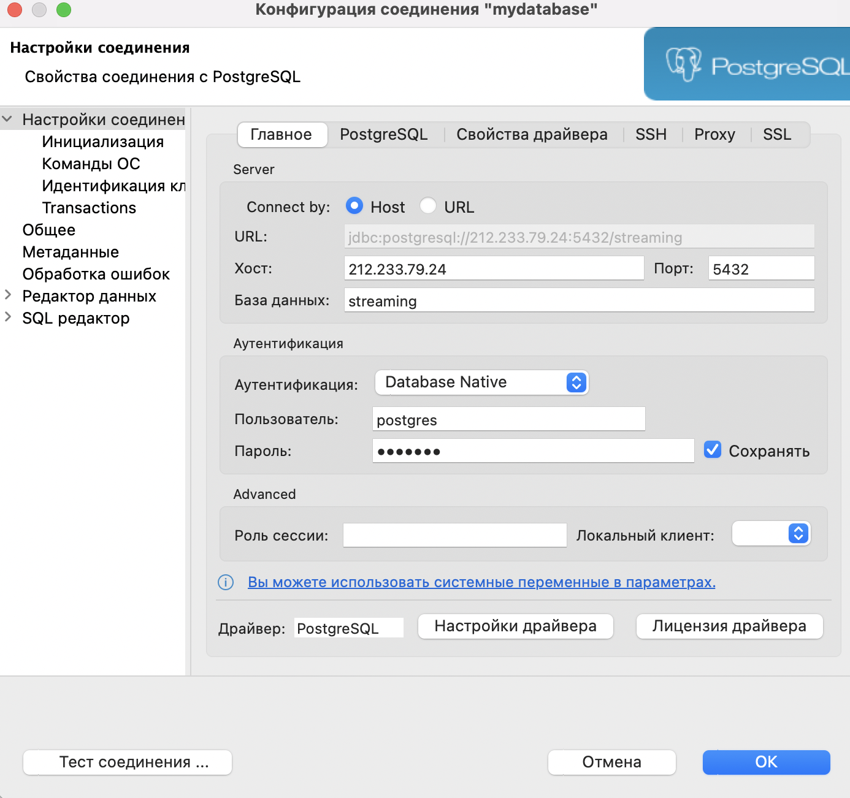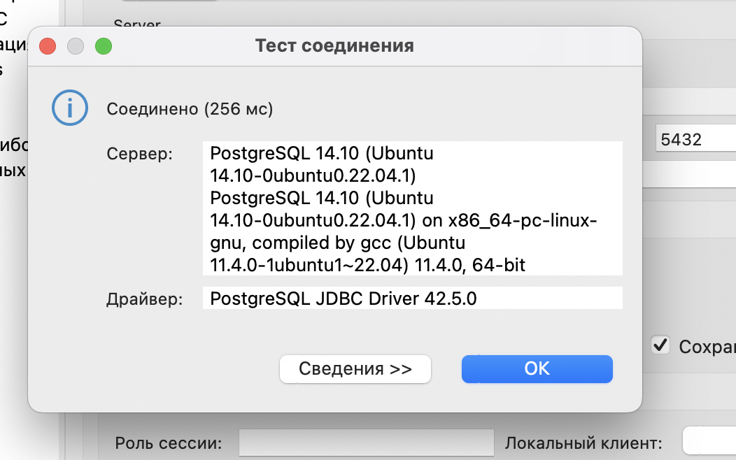

1. **Third Step:**

In the third step of the process, "Python Script for parsing and loading data," the task is to develop a Python script capable of parsing data. This involves crafting a script that can interpret and extract data from a given format, such as JSON or XML. Alongside this, a configuration file is created to hold the parameters that might change over time, like database connection details, which ensures the script is adaptable and easier to manage.

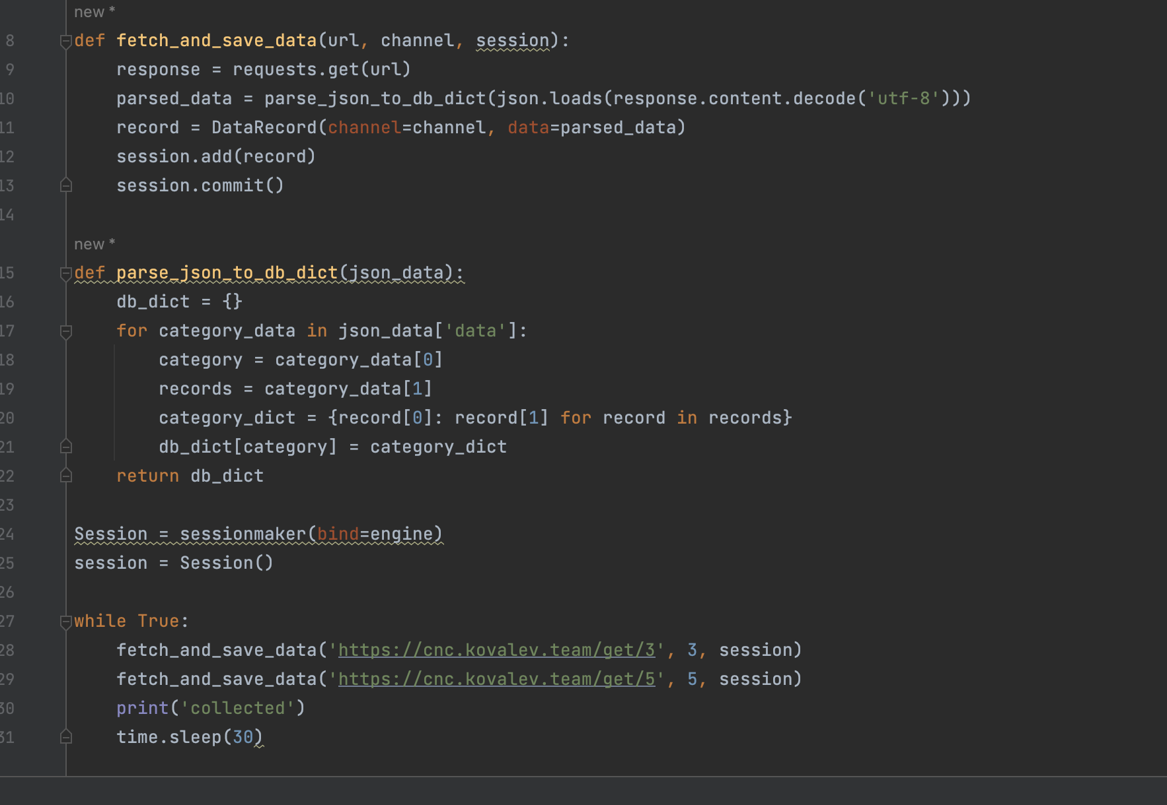

The next phase involves writing a Python script for loading the parsed data into the database. This script takes the data processed by the parsing script and inserts it into the database, handling any database interactions necessary for the data to be stored correctly.

To streamline the management and automation of this process, the Python script is added to the systemd on an Ubuntu server. By integrating the script as a systemd service, it becomes possible to start, stop, and restart the service as needed, and also to enable it to start automatically upon system boot, leveraging the robustness of the systemd init system.

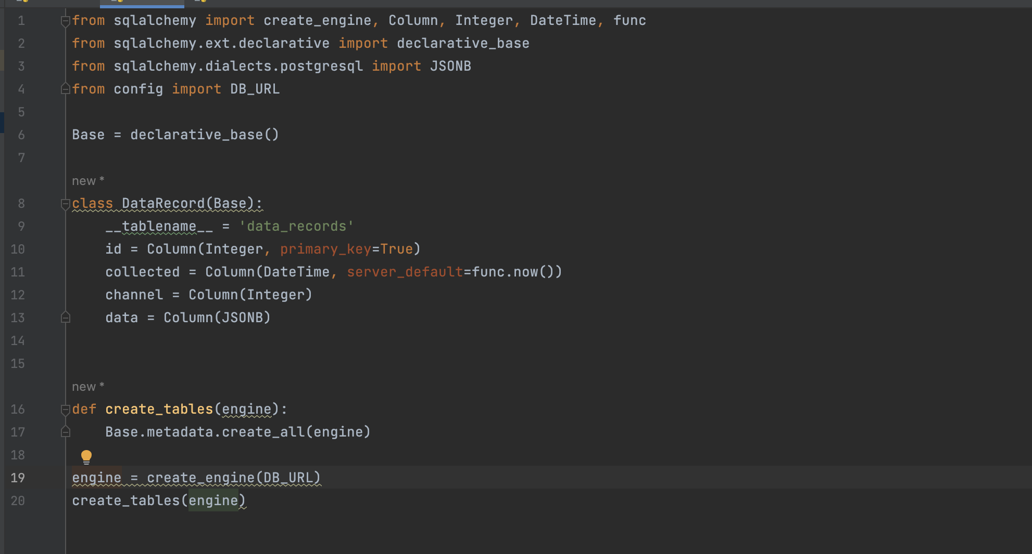

1. **Fourth Step:**

The fourth step, "Checking the correct creating of DB and loaded data," involves verifying the integrity and correctness of the database and the data loaded into it. This is typically done using a database management tool like DBeaver, which allows for comprehensive data inspection through a user-friendly interface.

The rationale behind limiting the database to only four columns is rooted in the need for flexibility due to the nature of JSON data, which can often contain varying parameters. By adopting a more dynamic structure, there is no need to alter the database schema each time new data types are introduced. This approach ensures that the database can handle new data without the need for constant modifications, thereby reducing the likelihood of load failures due to schema mismatches.

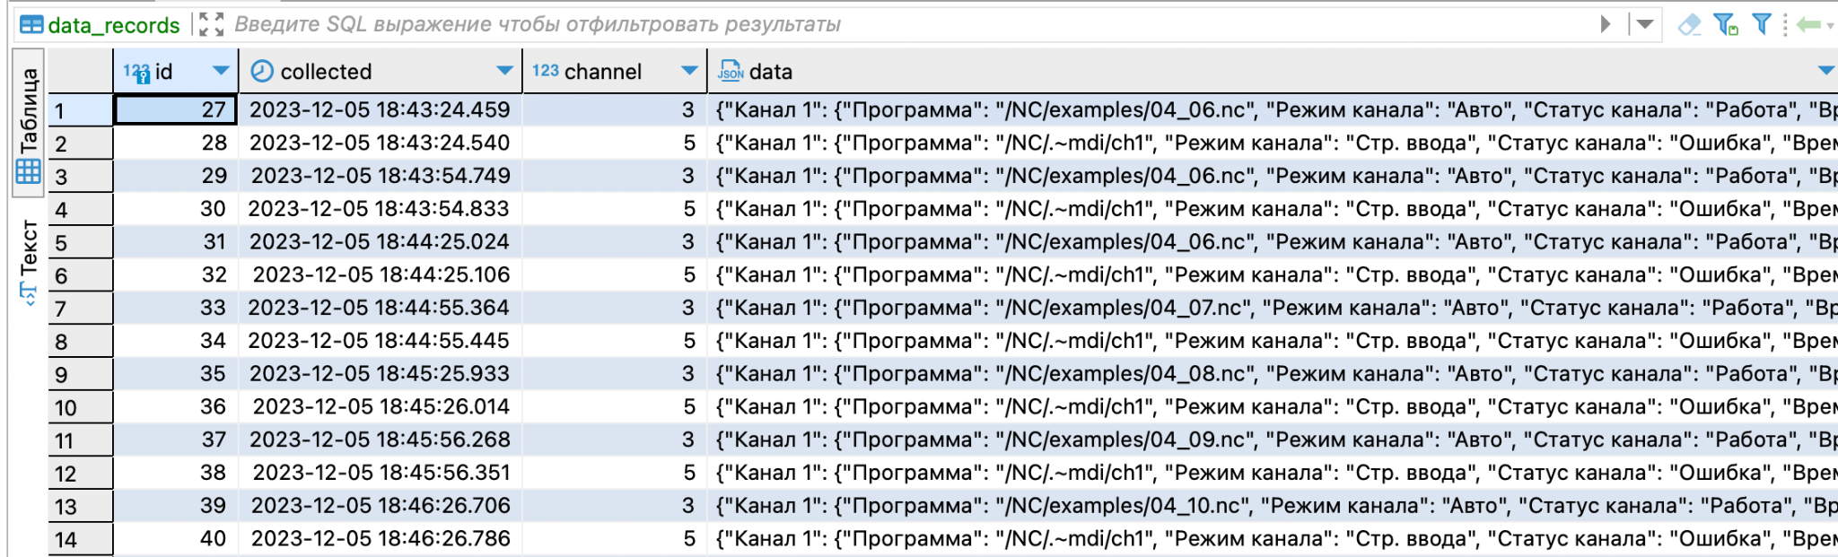

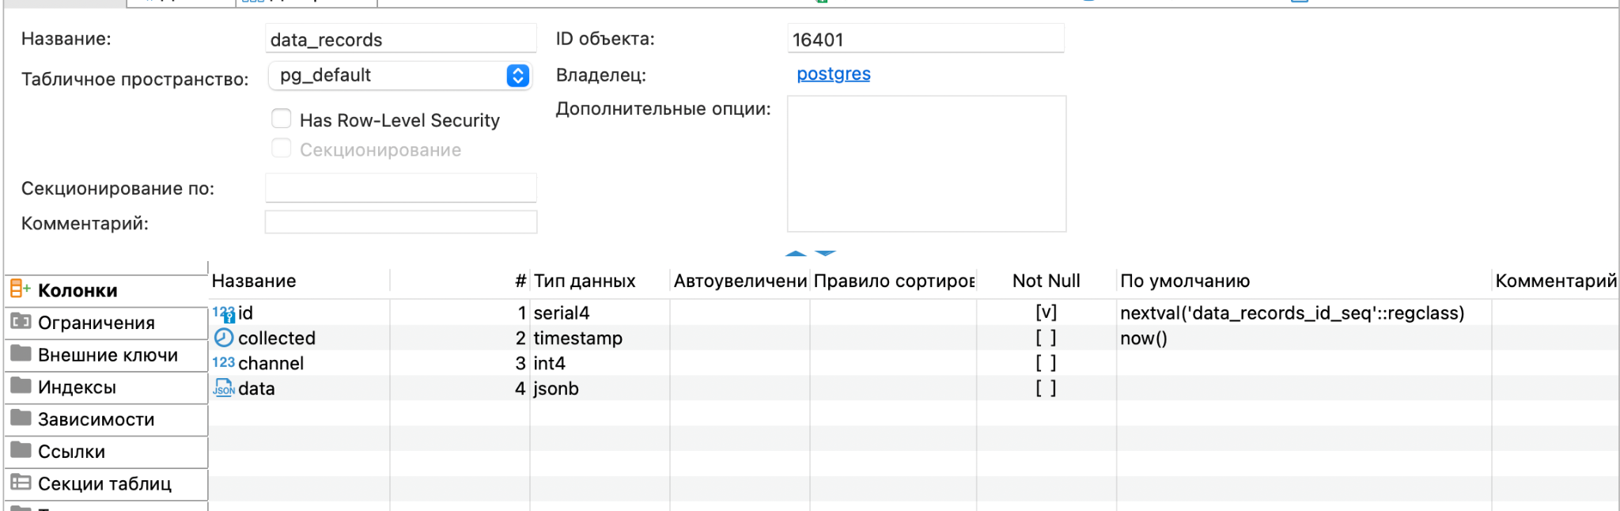

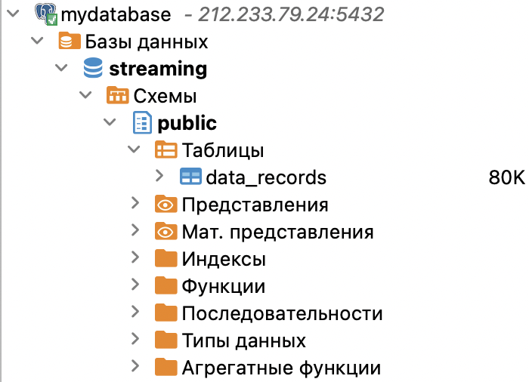

# Preparation Data

The Database stores data in JSON format, it is very difficult to analyze such undivided data, so it was necessary to separate this data into different columns and give it the correct format (string, number, date, etc.)

We used SQL for this procedure, we wrote a query to split the data and create new columns.

Screenshots of requests are presented below

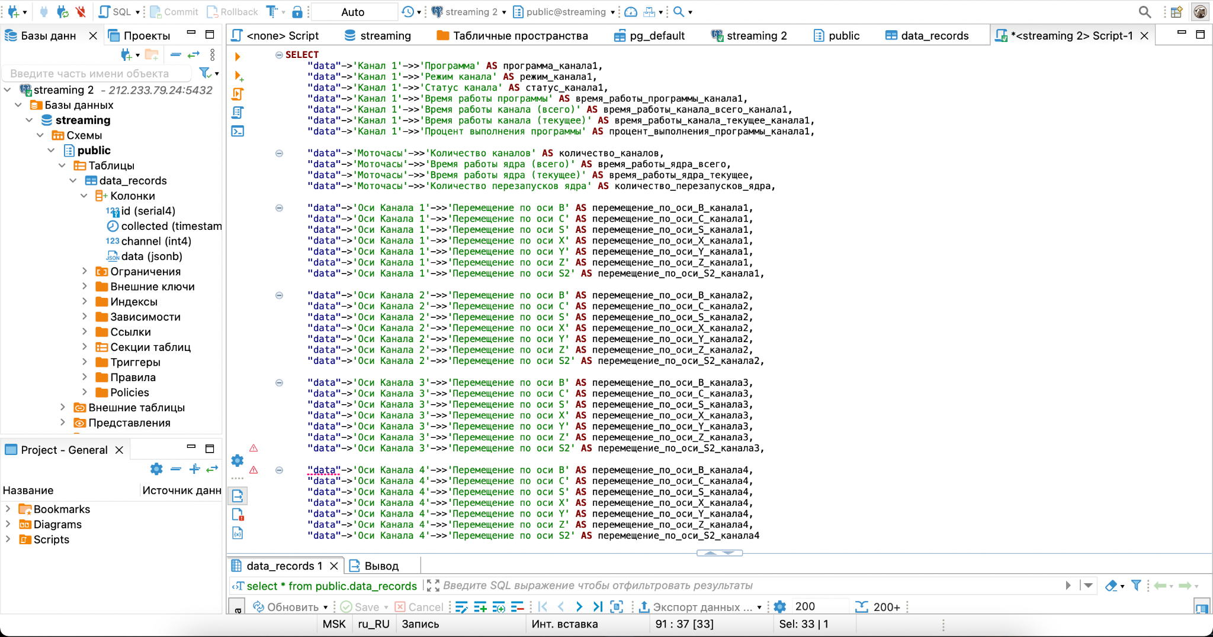

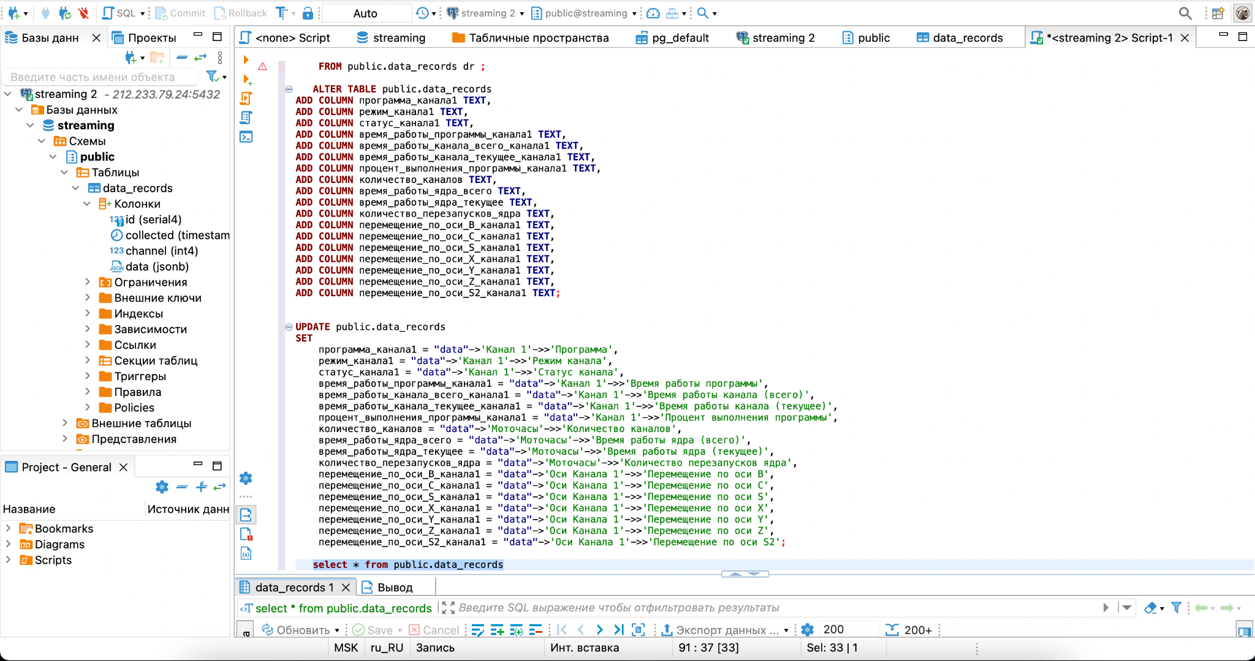

Now the converted database looks like this:

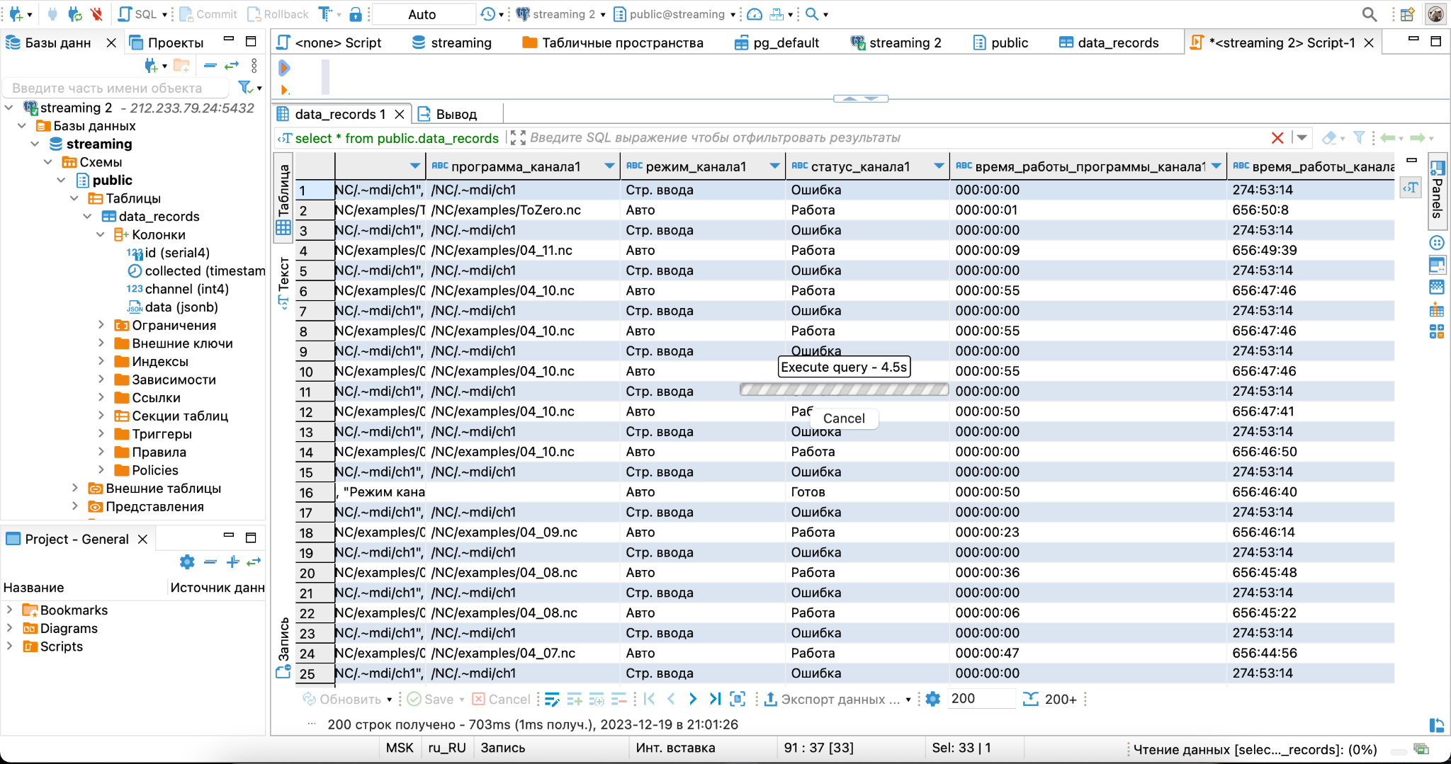

Data Visualization in Node-red

We set special library for Postgre SQL.To create a dashboard in node red, it was necessary to activate the server and connect to the database. The connection using the database was successful, but unfortunately it was not possible to generate analytics based on this data.

To connect to MQTT, connectors were configured and graphs were displayed for Demo and real data.

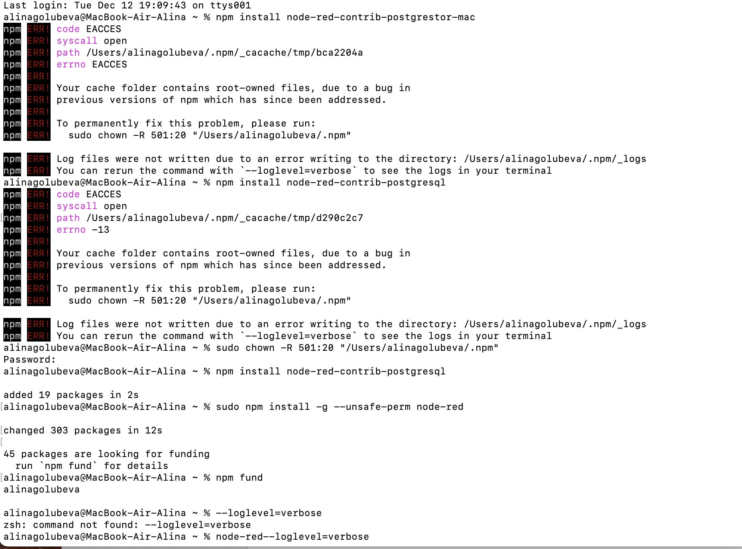

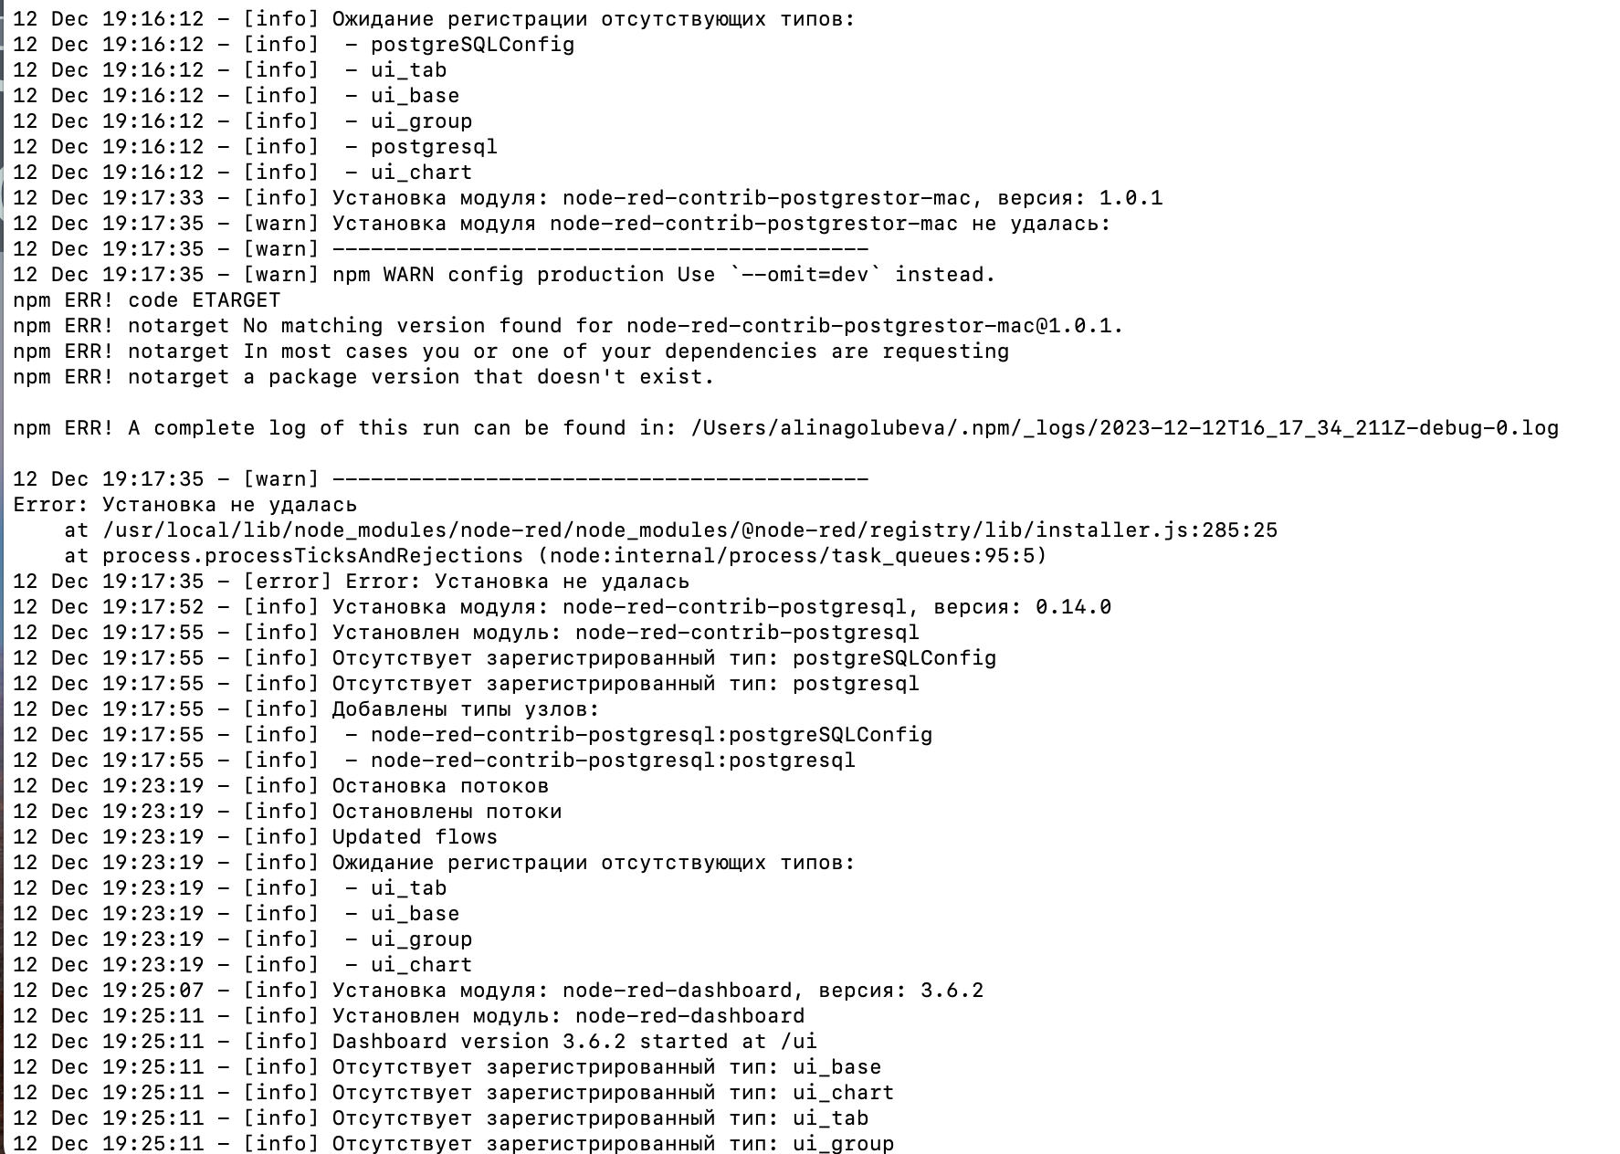

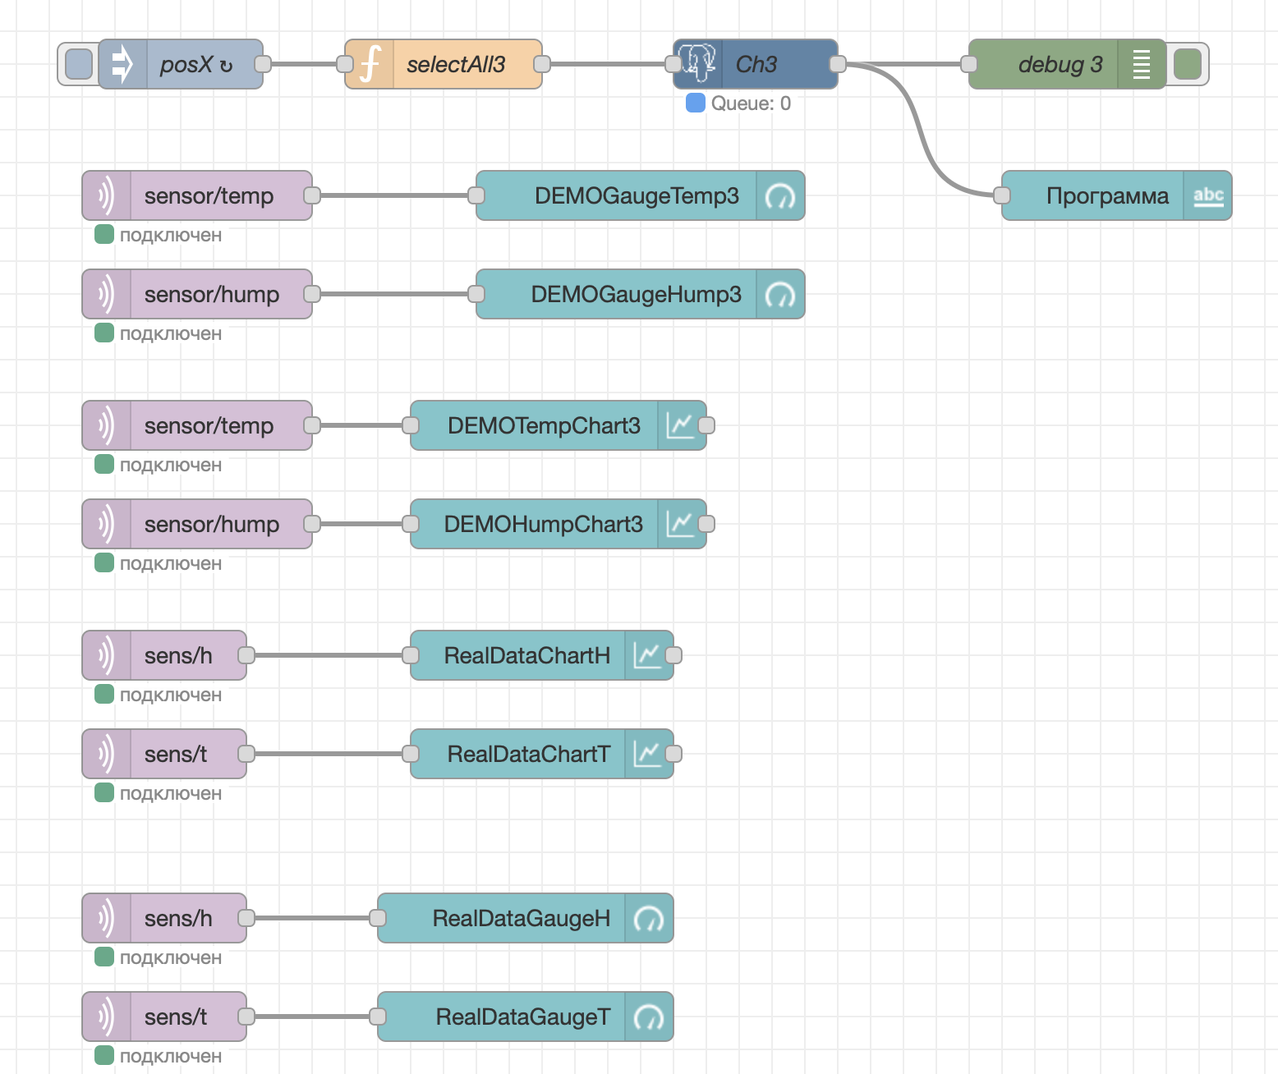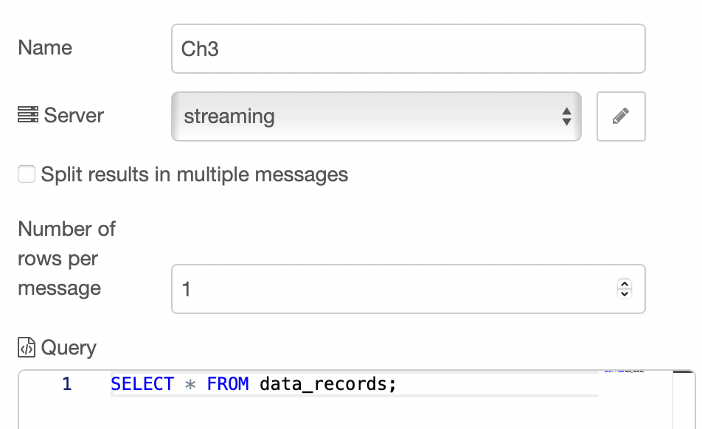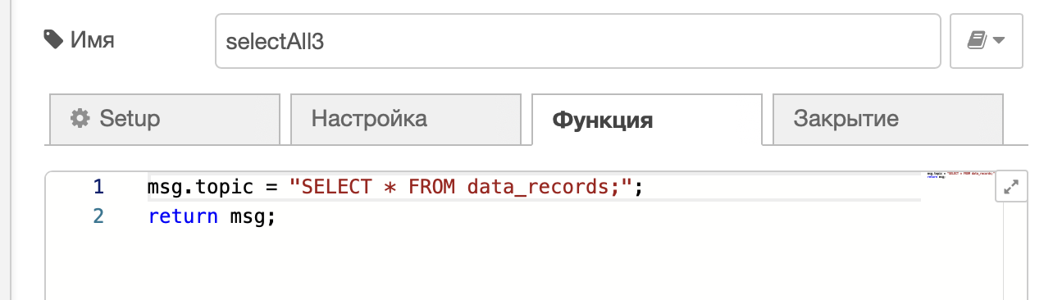

Dashboard in Node-red

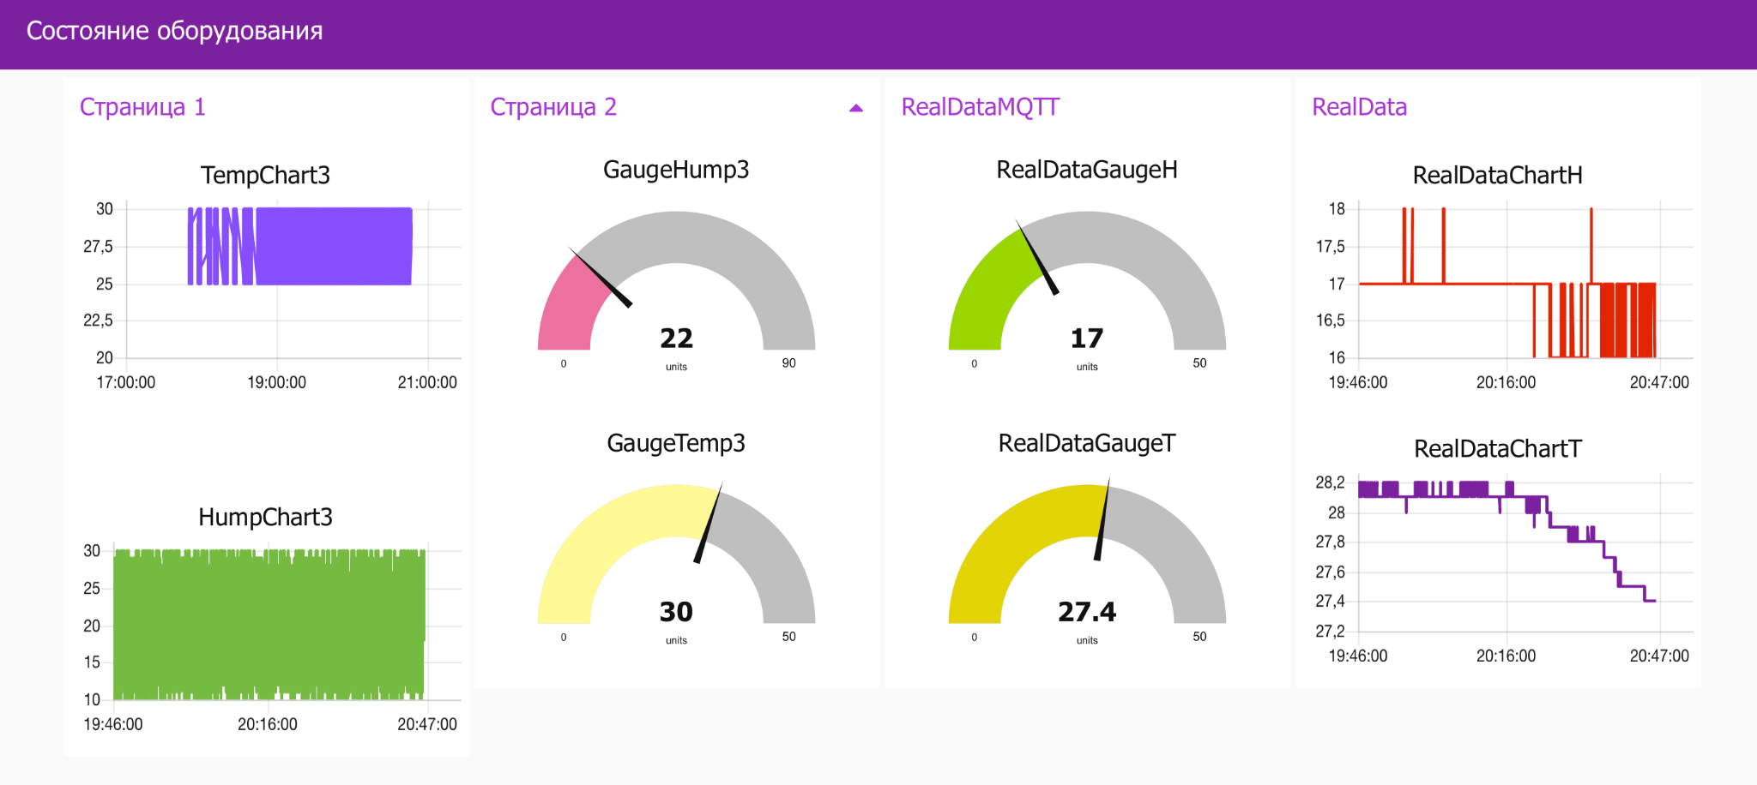

# 3. Analysis Data

We decided to use Python and Excel to analyze all the data like mode, state and programm of different channels.

Analysing in Python:

In order to build graphs in Python, we used the Pandas library and also imported the database that we had previously exported from DBeaver to Excel

This code loads data from an Excel file into a Python table. It uses the pandas library to read the 'Данные для анализа.xlsx' file from its first sheet and stores the data in the variable ‘df’.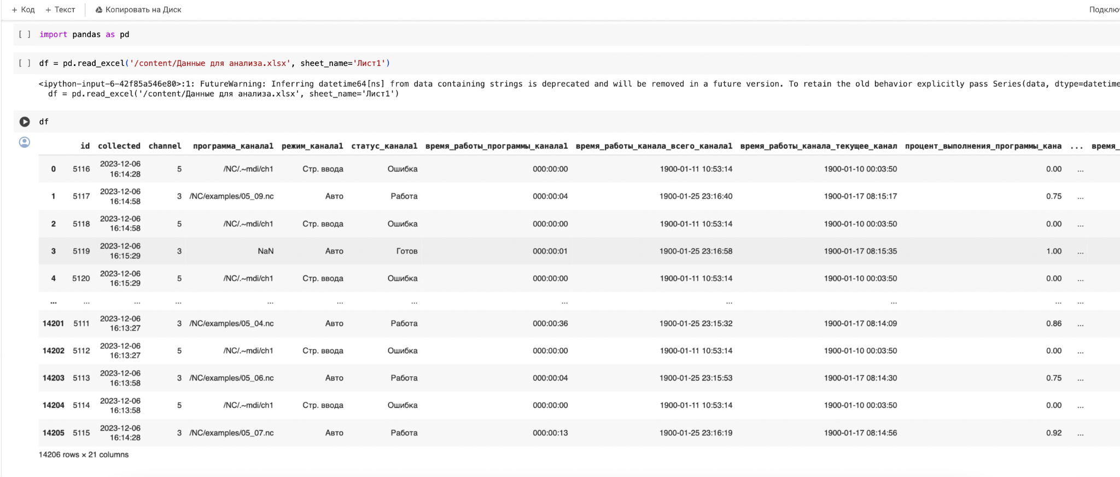

After this we created two new tables from the original table ‘df’, filtering it by the value in the 'channel' column. ‘df_3’ contains rows where 'channel' equals 3, and ‘df_5’ contains rows where 'channel' equals 5.

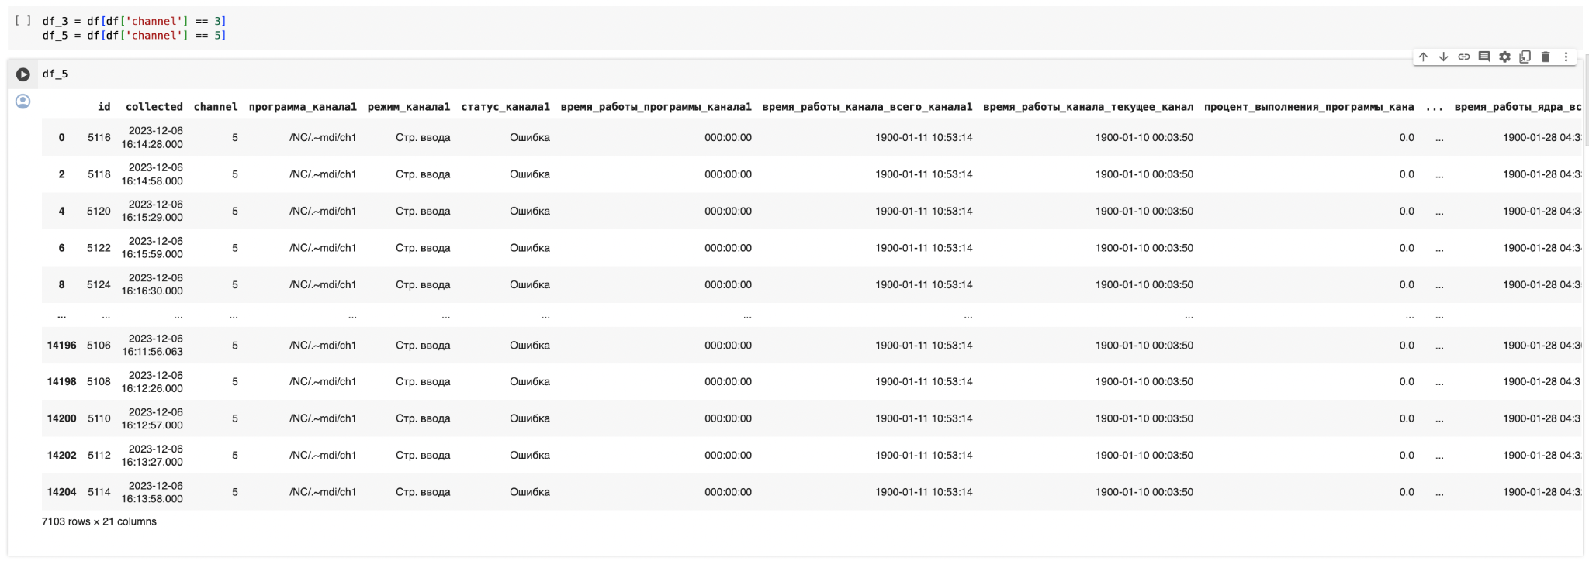

3.1.1 Most frequent state for channel 3  
Next, we create a bar chart for the 'статус_канала1' column in the df_3 table. Counting and sorting the unique values in the column allows for a clear visualization of the data. The chart is sized 20x8 and titled 'статус_канала1 для 3'.

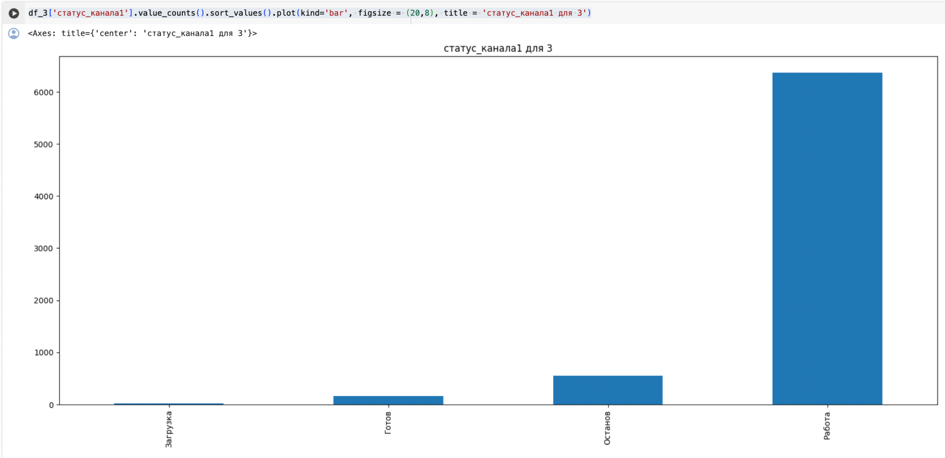

3.2.1 Most frequent programm for channel 3

Now, we create a bar chart for the 'программа_канала1' column in the `df_3` table. This visualizes the frequency of various programs on channel 3, showing how often each program occurs. The chart is 20x8 in size and titled 'программа_канала1 для 3'.

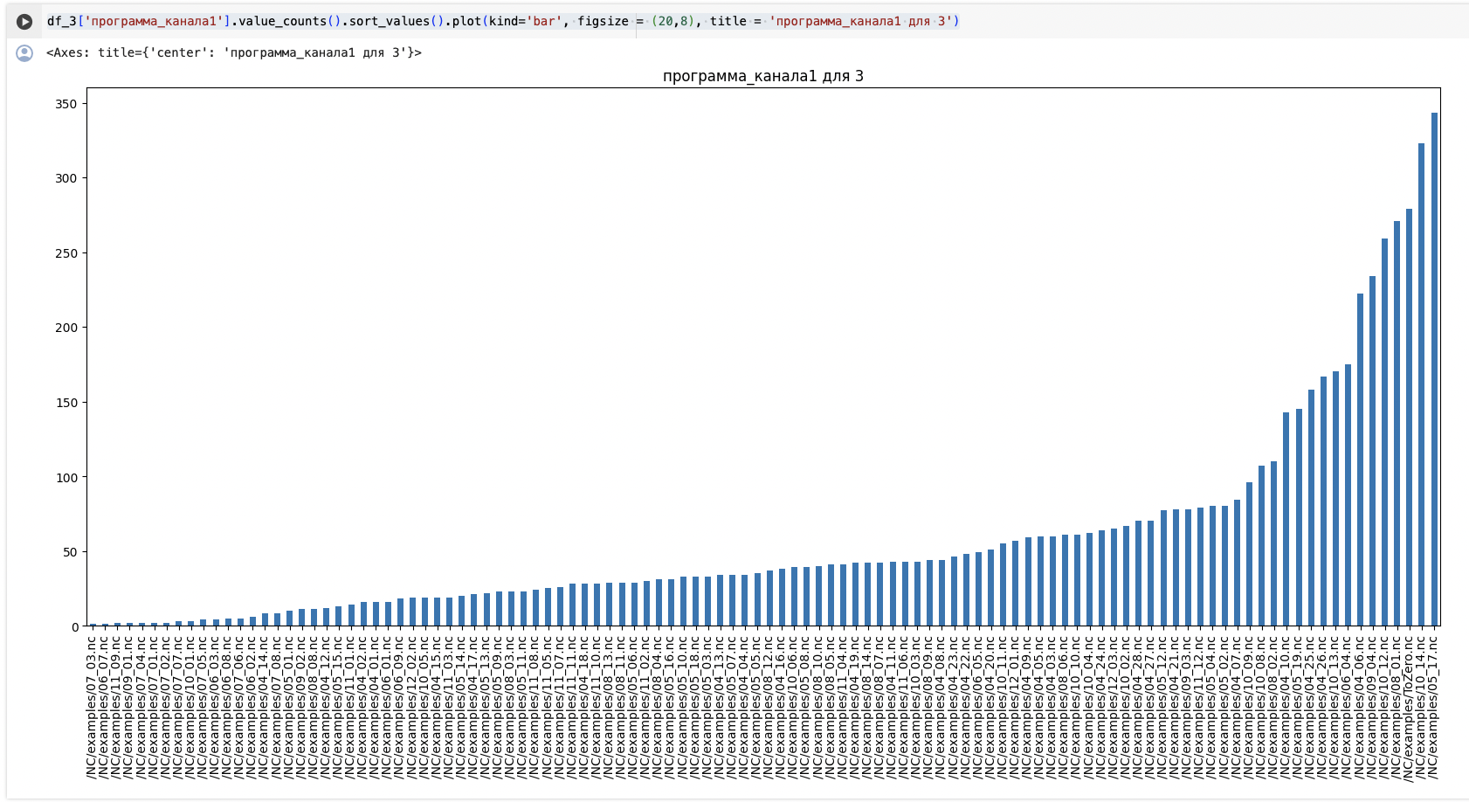

3.3.1 Most frequent mode for channel 3

Next, we create a bar chart to visualize data from the 'режим_канала1' column in the `df_3` table. This is done by counting unique values, sorting them, and displaying them on a chart sized 20x8. The chart's title is 'режим_канала1 для 3'.

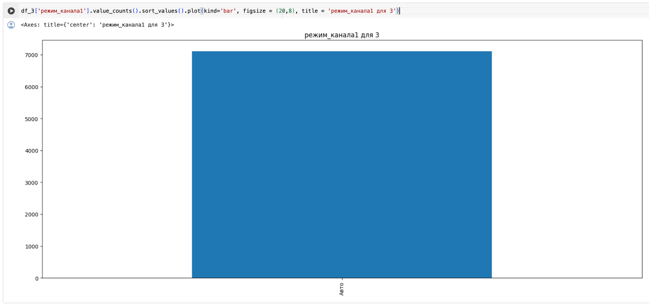

The same thing we did for channel 5:  
  
3.1.2 Most frequent state for channel 5

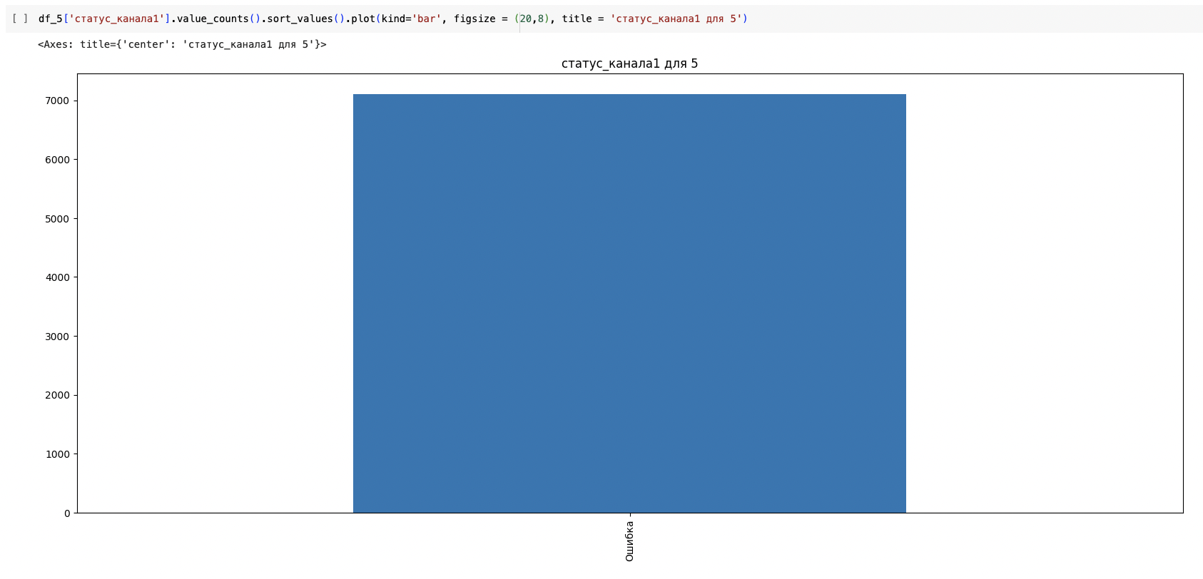

3.2.2 Most frequent programm for channel 5

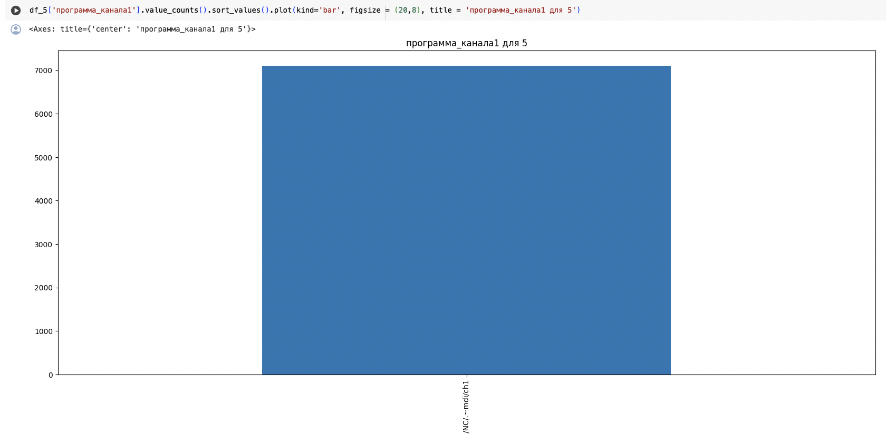

3.3.2 Most frequent mode for channel 5

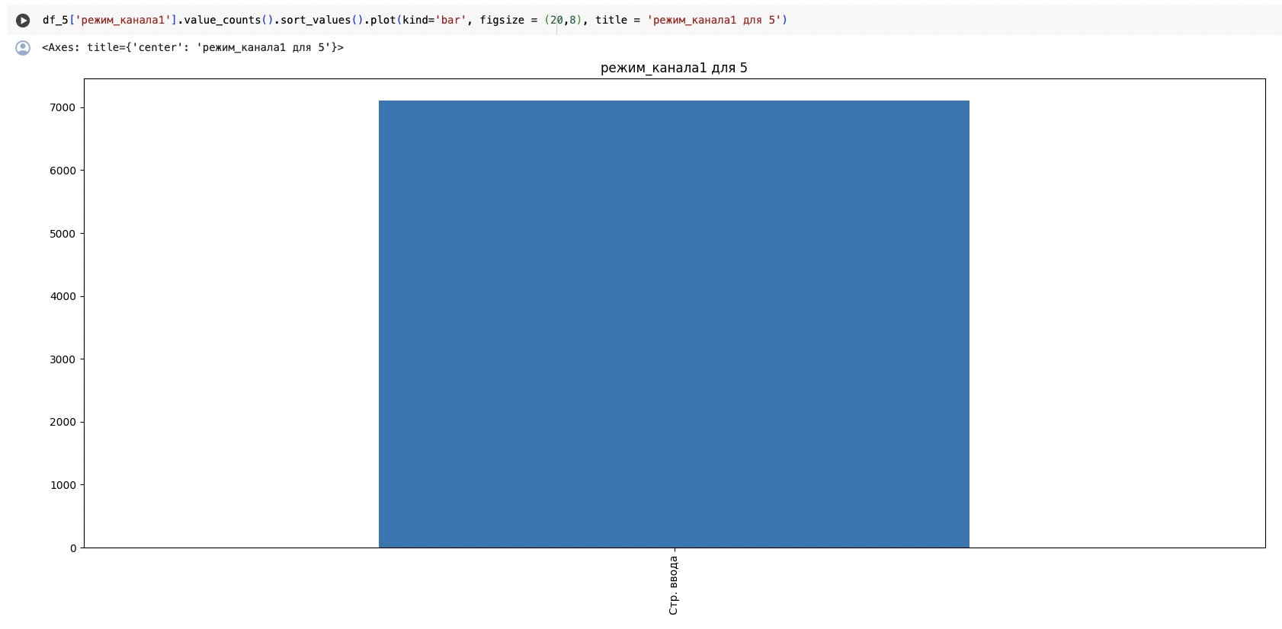

Data analyzed in Excel and graphs do not provide accurate information about the operating time of programs, since summation occurs in each line, and Excel does not have a function for counting the last values. A window function using ranking by channel and program (mode) is suitable for this (last_value(время_работы_программы) OVER( partition by channel, программа_канала1). This could not be implemented due to difficulties in changing data formats. Analytics in Excel shows data on percentage shares approximately in accordance with reality.

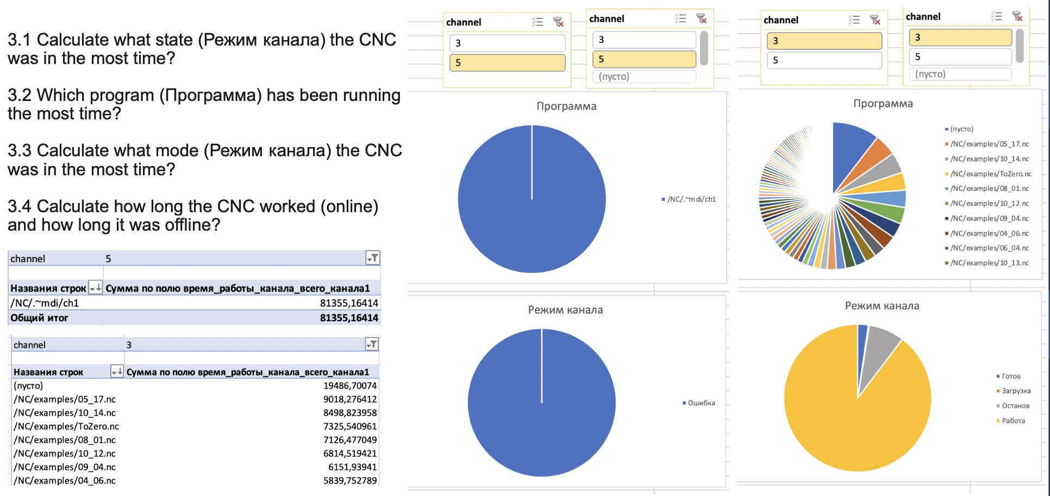

# 

# Notifications with Bot

First of all, I created a bot in telegram using @BotFather. The name is Manufacturing bot 2023 HSE or you can find it here <https://t.me/manu_stream_bot> (even though it doesn’t work without me PC)

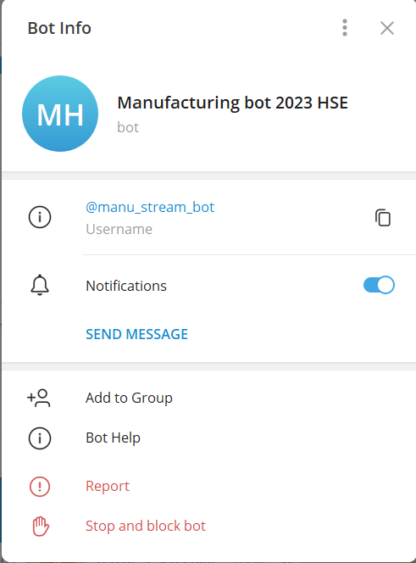

I created functions to check a status of each machine. Used a request package to get json files from each endpoint. Then checked the status of a machine and notified if there is a problem with it, providing its channel and error code.

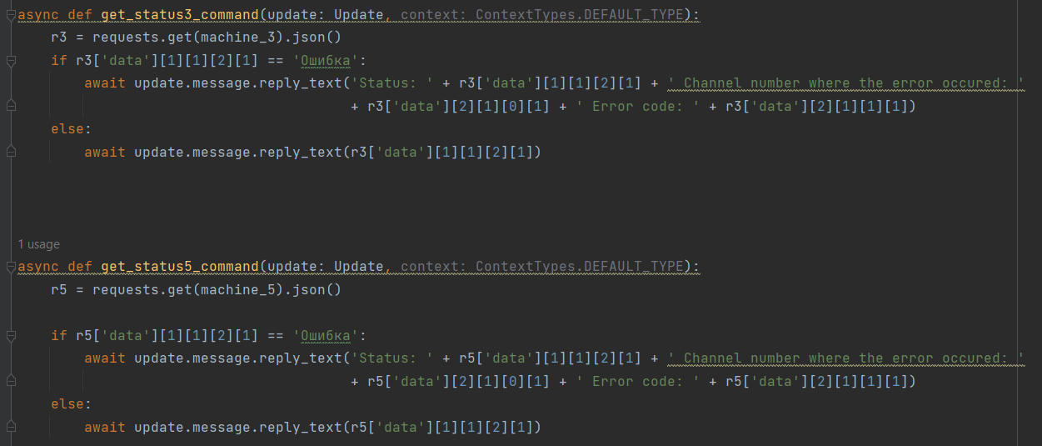

The next part is continuously checking for errors in a given machine and notify if there is an error. It also notifies if someone solves it.

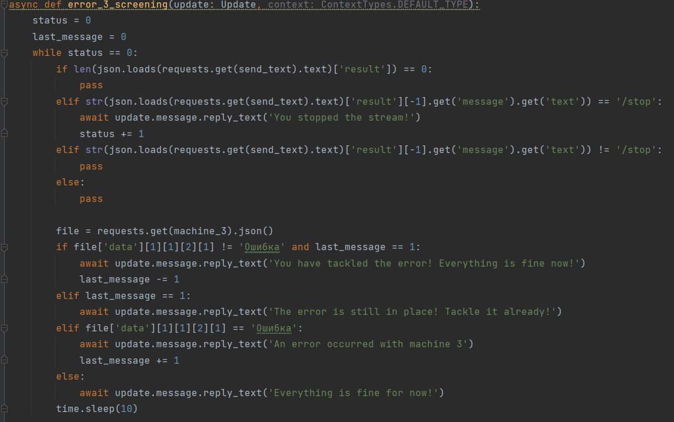

One of the functions called error_screening checks errors in both machines simultaneously to notify in case of errors.

The following part works with sensors’ data gained via MQTT using the paho-mqtt package. I used credentials provided to us and connected to the machine. It checks both humidity and temperature and sends messages if humidity gets above 70% and temperature gets above 30C.

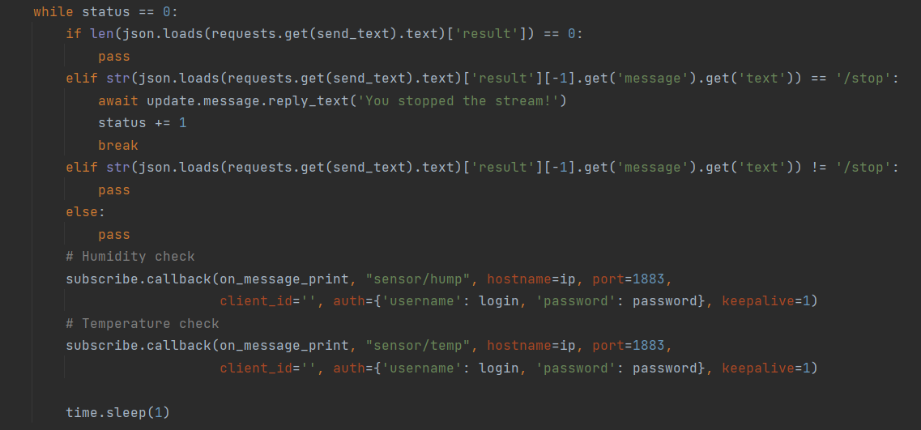

Each of the screening functions work on a loop until users send a message “/stop”. Each function checks the last message from the user and stops the loop if it receives such a message. It also sends a message notifying that a loop is interrupted.

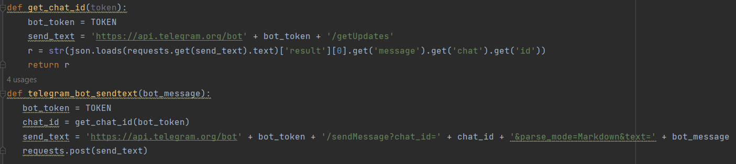

To start a bot you will need to insert Token in the TOKEN value in the upper part of the file.